**Calculator Assumed**

**Exponential Functions and Graphs**

Time: 45 minutes

Total Marks: 45

Your Score: / 45



**Question One: [3, 2, 2, 2 =9 marks]**

Consider the following functions:



1. State all the equations that represent exponential functions.
2. State the two equations which represent the same exponential function.
3. State the equations which represent increasing exponential functions.
4. State the equations which represent decreasing exponential functions.

**Question Two: [2, 2, 2, 2 = 8marks]**

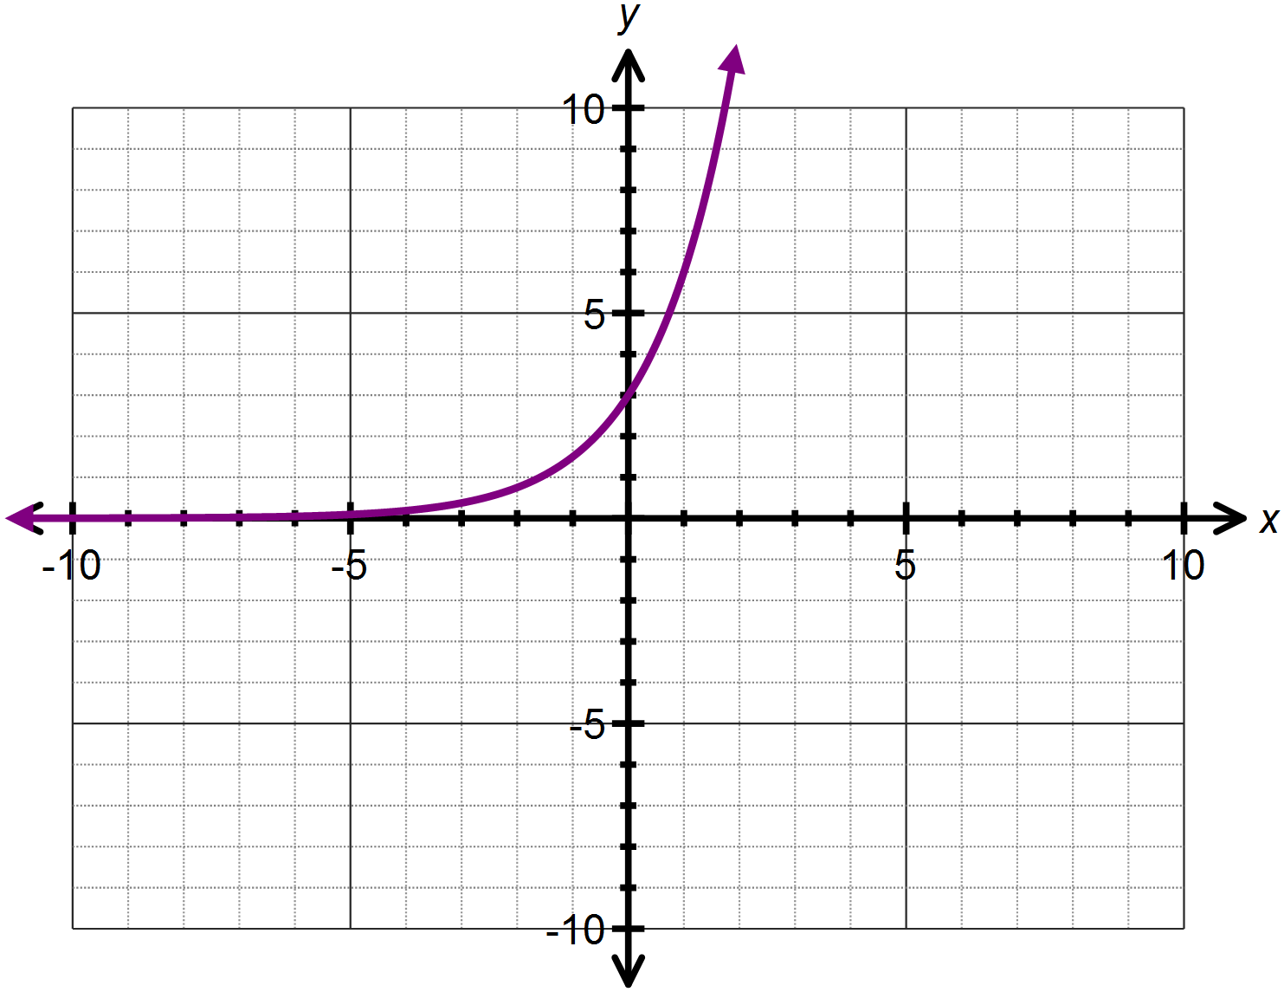Consider the graph of  drawn below.

1. Determine the equation of the function  .
2. State the domain and range of  .
3. Describe how the function  is transformed from  .
4. Sketch  on the axes above.

**Question Three: [4, 5 = 9 marks]**

Consider the function 

1. State the equation of the horizontal asymptote.
2. If the function is translated 4 units down, state the equation defining the new function.
3. Using your answer to part (ii) or otherwise, state the equation of the asymptote for the newly translated function.
4. State the coordinate for the *y-*intercept of the newly translated function.
5. If the function is translated 2 units left, determine:
6. Two equivalent expressions which define the newly translated function.
7. Where the *y*- intercept has been translated to.
8. The *y –* intercept of the newly translated function.

**Question Four: [2, 2, 2, 2, 3, 3 =14 marks]**

Determine the equation of each of the following functions:

1. 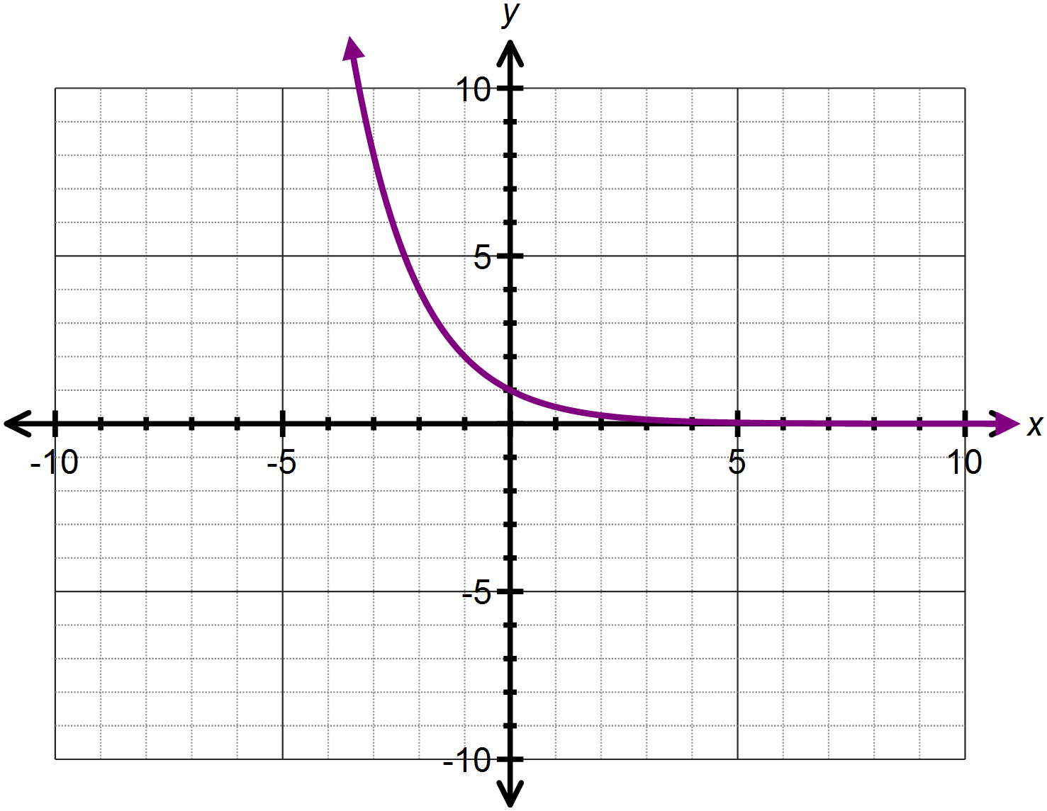

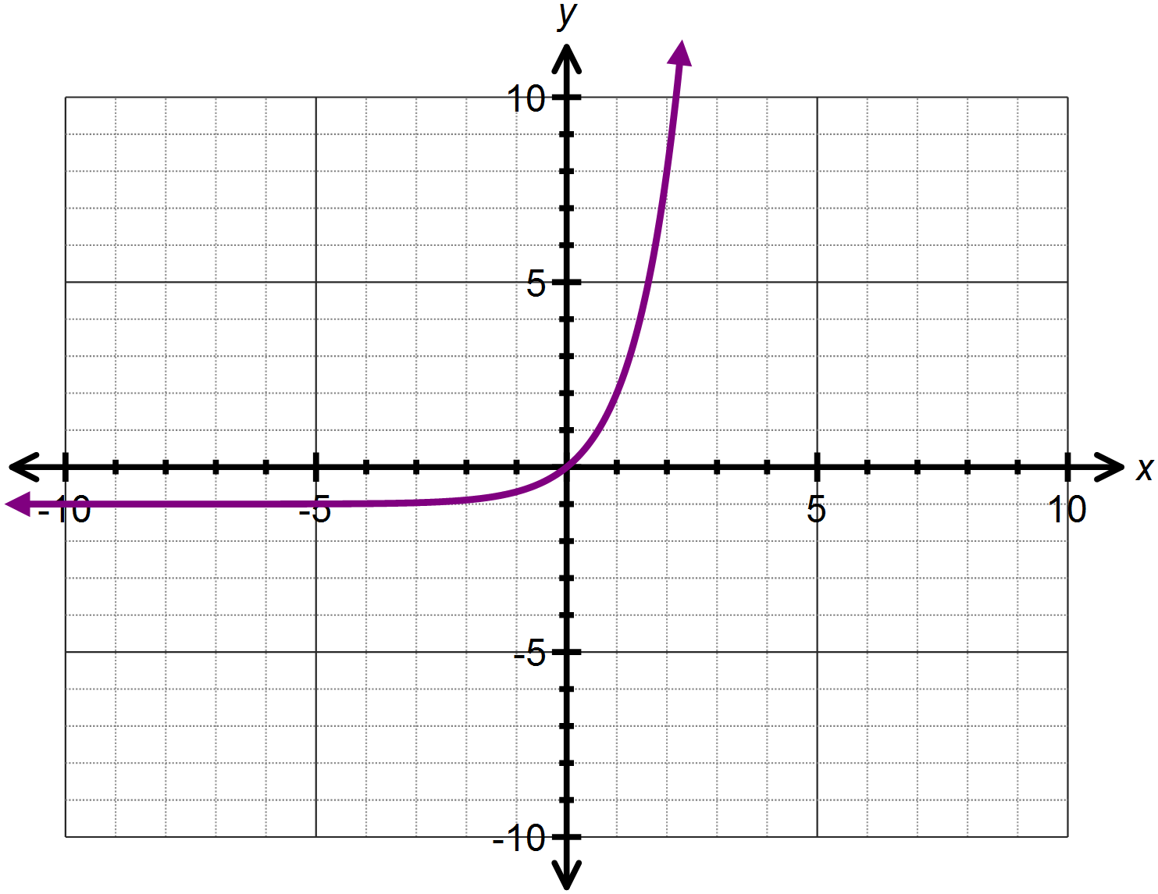

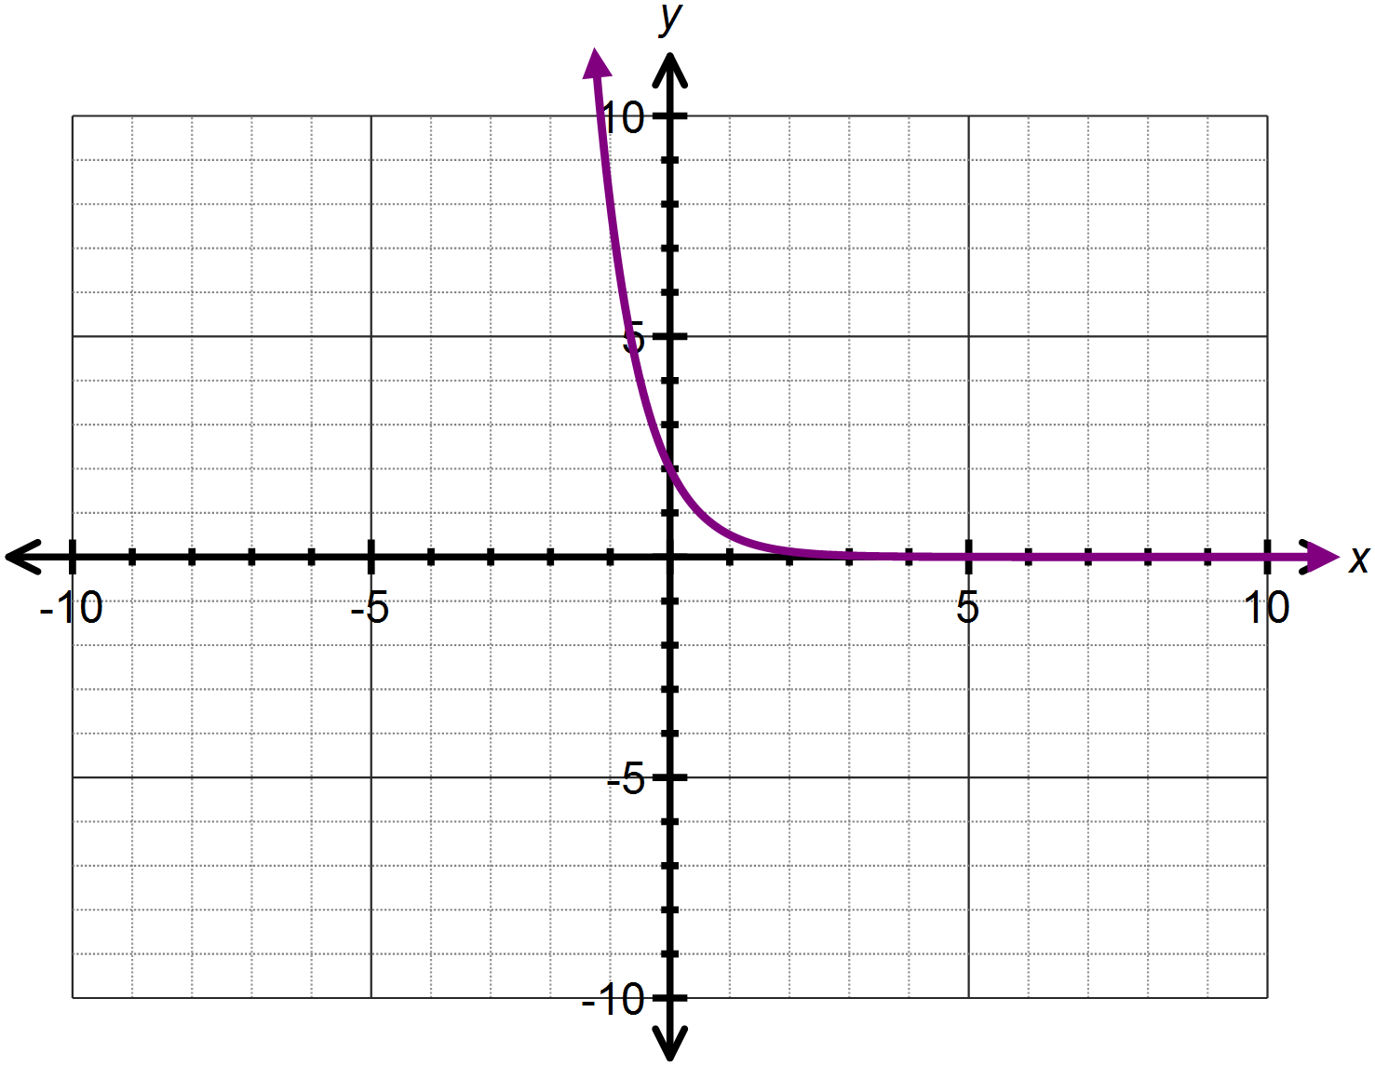

1. 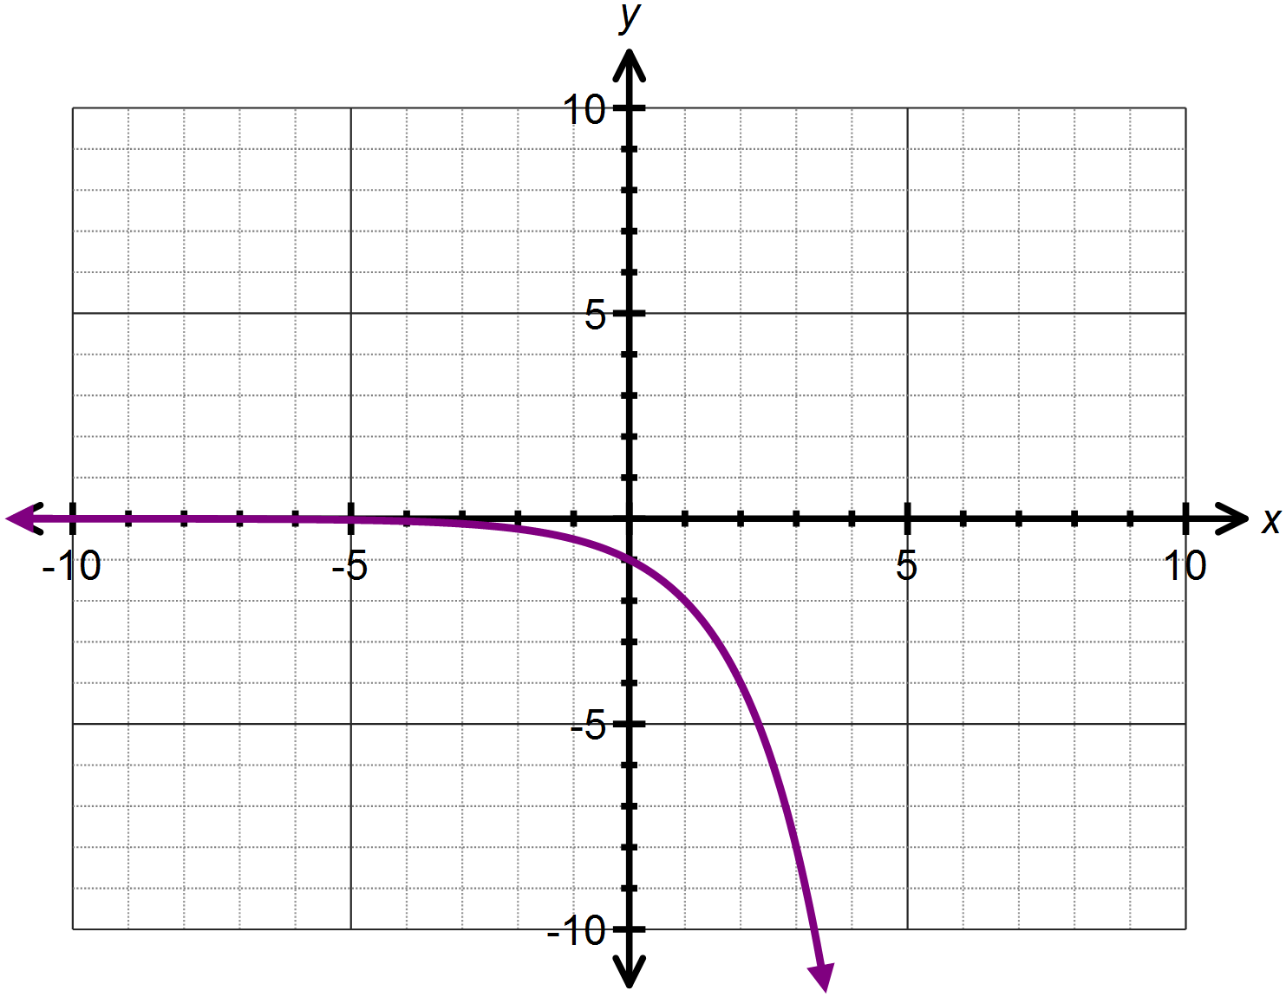

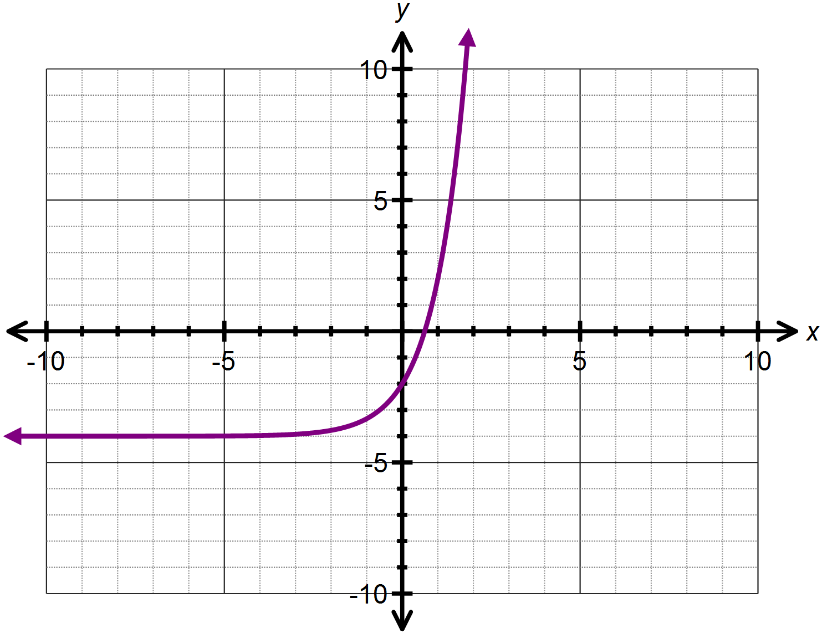

1. 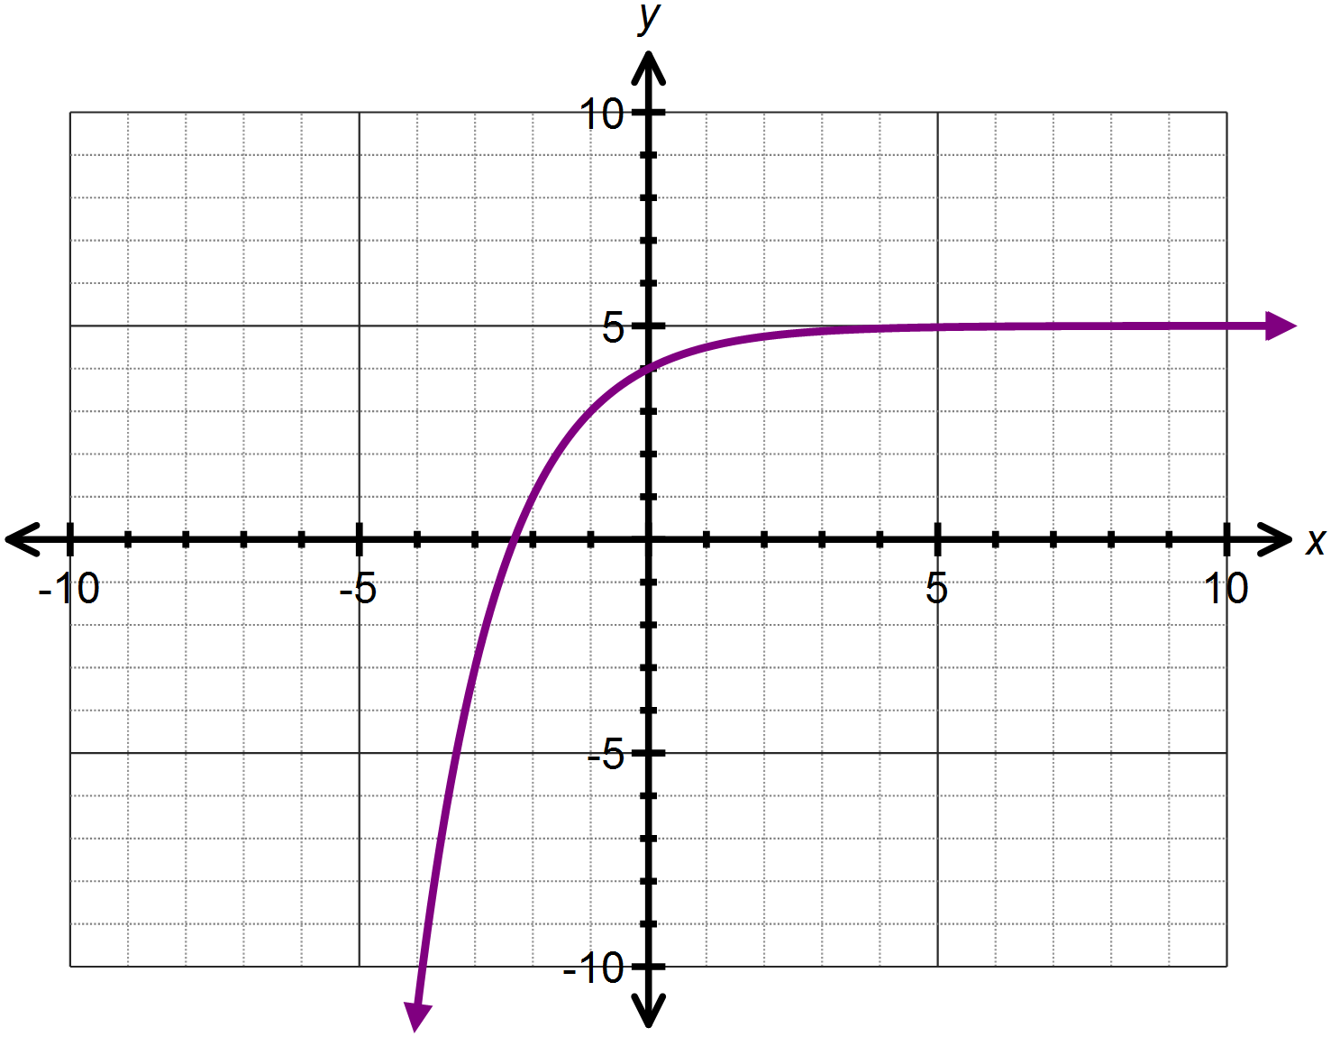

**Question Five: [2, 2, 1 = 5 marks]**

The function  has been transformed and now has equation 

1. Describe the two transformations that have occurred.
2. These two transformations are the equivalent of one single transformation. State the single transformation which results in the same function.
3. Hence or otherwise determine the *y* – intercept of the transformed function.

**SOLUTIONS**

**Calculator Assumed**

**Exponential Functions and Graphs**

Time: 45 minutes

Total Marks: 45

Your Score: / 45



**Question One: [3, 2, 2, 2 =9 marks]**

Consider the following functions:



1. State all the equations that represent exponential functions.



1. State the two equations which represent the same exponential function.



1. State the equations which represent increasing exponential functions.



1. State the equations which represent decreasing exponential functions.



**Question Two: [2, 2, 2, 2 = 8marks]**

Consider the graph of  drawn below.





1. Determine the equation of the function  .



1. State the domain and range of  .



1. Describe how the function  is transformed from  .



1. Sketch  on the axes above.

**Question Three: [4, 5 = 9 marks]**

Consider the function 

1. State the equation of the horizontal asymptote.



1. If the function is translated 4 units down, state the equation defining the new function.



1. Using your answer to part (ii) or otherwise, state the equation of the asymptote for the newly translated function.



1. State the coordinate for the *y-*intercept of the newly translated function.



1. If the function is translated 2 units left, determine:
2. Two equivalent expressions which define the newly translated function.



1. Where the *y*- intercept has been translated to.



1. The *y –* intercept of the newly translated function.



**Question Four: [2, 2, 2, 2, 3, 3 =14 marks]**

Determine the equation of each of the following functions:

1.  



1.  



1.  
2.  





1.  
2.  



**Question Five: [2, 2, 1 = 5 marks]**

The function  has been transformed and now has equation 

1. Describe the two transformations that have occurred.



1. These two transformations are the equivalent of one single transformation. State the single transformation which results in the same function.



1. Hence or otherwise determine the *y* – intercept of the transformed function.

